**Candidate Name**:- AMRUTHA H

**Superset ID**:-6421402

**WEEK – 3 HANDS ON EXERCISE (JAVA FSE DEEPSKILLING)**

**Module 5 - Spring Core and Maven**

**Exercise 1: Configuring a Basic Spring Application**

**Scenario:**

Your company is developing a web application for managing a library. You need to use the Spring Framework to handle the backend operations.

**Steps:**

1. **Set Up a Spring Project:**
   * Create a Maven project named **LibraryManagement**.
   * Add Spring Core dependencies in the **pom.xml** file.
2. **Configure the Application Context:**
   * Create an XML configuration file named **applicationContext.xml** in the **src/main/resources** directory.
   * Define beans for **BookService** and **BookRepository** in the XML file.
3. **Define Service and Repository Classes:**
   * Create a package **com.library.service** and add a class **BookService**.
   * Create a package **com.library.repository** and add a class **BookRepository**.
4. **Run the Application:**
   * Create a main class to load the Spring context and test the configuration.

**SOLUTION:**

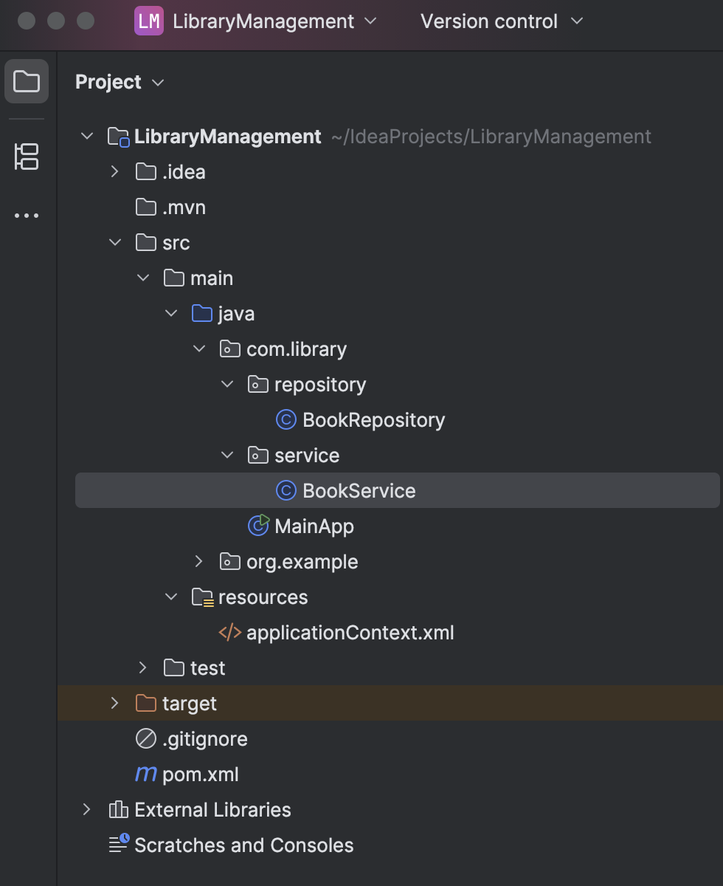

**pom.xml**

<project xmlns="http://maven.apache.org/POM/4.0.0" xmlns:xsi="http://www.w3.org/2001/XMLSchema-instance"

xsi:schemaLocation="http://maven.apache.org/POM/4.0.0 http://maven.apache.org/xsd/maven-4.0.0.xsd">

<modelVersion>4.0.0</modelVersion>

<groupId>org.example</groupId>

<artifactId>LibraryManagement</artifactId>

<version>1.0-SNAPSHOT</version>

<packaging>jar</packaging>

<name>LibraryManagement</name>

<url>http://maven.apache.org</url>

<properties>

<project.build.sourceEncoding>UTF-8</project.build.sourceEncoding>

</properties>

<dependencies>

<dependency>

<groupId>junit</groupId>

<artifactId>junit</artifactId>

<version>3.8.1</version>

<scope>test</scope>

</dependency>

<dependency>

<groupId>org.springframework</groupId>

<artifactId>spring-context</artifactId>

<version>5.3.31</version>

</dependency>

</dependencies>

</project>

**BookRepository.java**

package com.library.repository;

public class BookRepository {

public void saveBook(String bookName) {

System.*out*.println("Saving book: " + bookName);

}

}

**BookService.java**

package com.library.service;

import com.library.repository.BookRepository;

public class BookService {

private BookRepository bookRepository;

public void setBookRepository(BookRepository bookRepository) {

this.bookRepository = bookRepository;

}

public void addBook(String bookName) {

System.*out*.println("Adding book in service...");

bookRepository.saveBook(bookName);

}

}

**applicationContext.xml**

<?xml version="1.0" encoding="UTF-8"?>

<beans xmlns="http://www.springframework.org/schema/beans"

xmlns:xsi="http://www.w3.org/2001/XMLSchema-instance"

xsi:schemaLocation="

http://www.springframework.org/schema/beans

http://www.springframework.org/schema/beans/spring-beans.xsd">

<bean id="bookRepository" class="com.library.repository.BookRepository"/>

<bean id="bookService" class="com.library.service.BookService">

<property name="bookRepository" ref="bookRepository"/>

</bean>

</beans>

**LibraryManagementApplication.java**

package com.library;

import com.library.service.BookService;

import org.springframework.context.ApplicationContext;

import org.springframework.context.support.ClassPathXmlApplicationContext;

public class MainApp {

public static void main(String[] args) {

ApplicationContext context = new ClassPathXmlApplicationContext("applicationContext.xml");

BookService service = context.getBean("bookService", BookService.class);

service.addBook("The Great Gatsby");

}

}

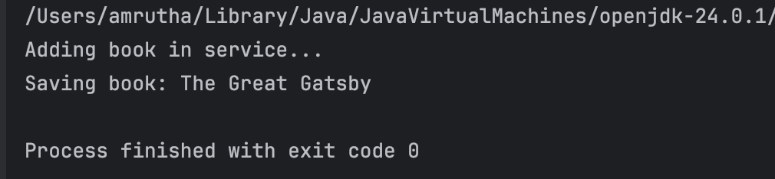

**Exercise 2: Implementing Dependency Injection**

**Scenario:**

In the library management application, you need to manage the dependencies between the BookService and BookRepository classes using Spring's IoC and DI.

**Steps:**

1. **Modify the XML Configuration:**
   * Update **applicationContext.xml** to wire **BookRepository** into **BookService**.
2. **Update the BookService Class:**
   * Ensure that **BookService** class has a setter method for **BookRepository**.
3. **Test the Configuration:**
   * Run the **LibraryManagementApplication** main class to verify the dependency injection.

**SOLUTION:**

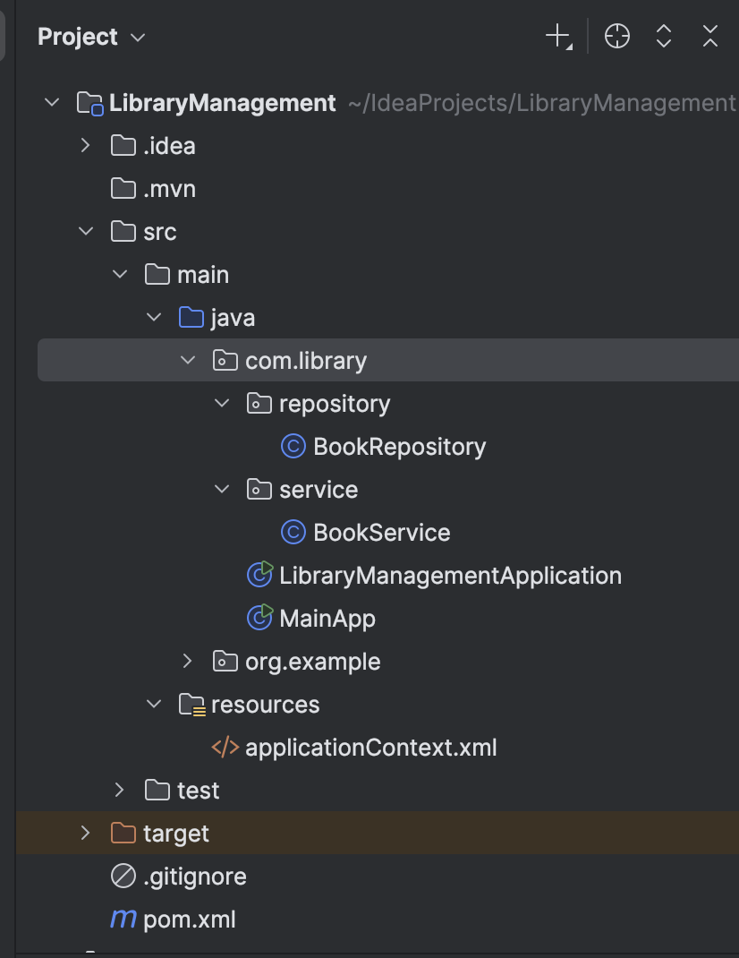

**LibraryManagementApplication.java**

package com.library;

import com.library.service.BookService;

import org.springframework.context.ApplicationContext;

import org.springframework.context.support.ClassPathXmlApplicationContext;

public class LibraryManagementApplication {

public static void main(String[] args) {

ApplicationContext context = new ClassPathXmlApplicationContext("applicationContext.xml");

BookService service = (BookService) context.getBean("bookService");

service.addBook("The Alchemist");

}

}

**BookRepository.java**

package com.library.repository;

public class BookRepository {

public void saveBook(String book) {

System.*out*.println("BookRepository: Saving book - " + book);

}

}

**BookService.java**

package com.library.service;

import com.library.repository.BookRepository;

public class BookService {

private BookRepository bookRepository;

public void setBookRepository(BookRepository bookRepository) {

this.bookRepository = bookRepository;

}

public void addBook(String book) {

bookRepository.saveBook(book);

System.*out*.println("BookService: Book added successfully.");

}

}

**applicationContext.xml**

<?xml version="1.0" encoding="UTF-8"?>

<beans xmlns="http://www.springframework.org/schema/beans"

xmlns:xsi="http://www.w3.org/2001/XMLSchema-instance"

xsi:schemaLocation="

http://www.springframework.org/schema/beans

http://www.springframework.org/schema/beans/spring-beans.xsd">

<bean id="bookRepository" class="com.library.repository.BookRepository"/>

<bean id="bookService" class="com.library.service.BookService">

<property name="bookRepository" ref="bookRepository"/>

</bean>

</beans>

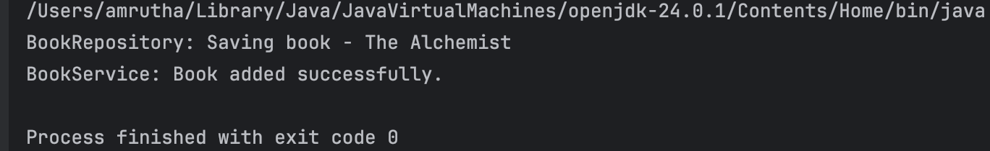

**Exercise 4: Creating and Configuring a Maven Project**

**Scenario:**

You need to set up a new Maven project for the library management application and add Spring dependencies.

**Steps:**

1. **Create a New Maven Project:**
   * Create a new Maven project named **LibraryManagement**.
2. **Add Spring Dependencies in pom.xml:**
   * Include dependencies for Spring Context, Spring AOP, and Spring WebMVC.
3. **Configure Maven Plugins:**
   * Configure the Maven Compiler Plugin for Java version 1.8 in the pom.xml file.

**Solution:**

**Created the project LibraryManagement**

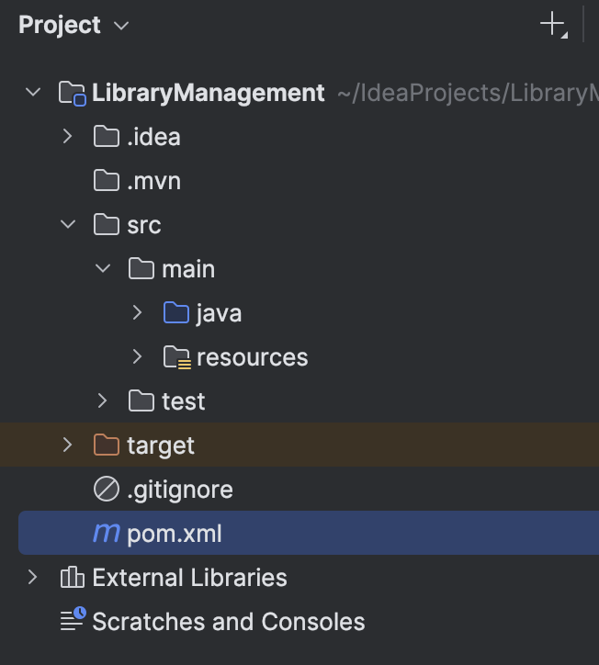

**Pom.xml**

<project xmlns="http://maven.apache.org/POM/4.0.0"

xmlns:xsi="http://www.w3.org/2001/XMLSchema-instance"

xsi:schemaLocation="http://maven.apache.org/POM/4.0.0 http://maven.apache.org/xsd/maven-4.0.0.xsd">

<modelVersion>4.0.0</modelVersion>

<groupId>com.library</groupId>

<artifactId>LibraryManagement</artifactId>

<version>1.0-SNAPSHOT</version>

<properties>

<maven.compiler.source>1.8</maven.compiler.source>

<maven.compiler.target>1.8</maven.compiler.target>

<project.build.sourceEncoding>UTF-8</project.build.sourceEncoding>

</properties>

<dependencies>

<dependency>

<groupId>org.springframework</groupId>

<artifactId>spring-context</artifactId>

<version>5.3.31</version>

</dependency>

<dependency>

<groupId>org.springframework</groupId>

<artifactId>spring-aop</artifactId>

<version>5.3.31</version>

</dependency>

<dependency>

<groupId>org.springframework</groupId>

<artifactId>spring-webmvc</artifactId>

<version>5.3.31</version>

</dependency>

</dependencies>

<build>

<plugins>

<!-- Java Compiler Plugin -->

<plugin>

<groupId>org.apache.maven.plugins</groupId>

<artifactId>maven-compiler-plugin</artifactId>

<version>3.8.1</version>

<configuration>

<source>1.8</source>

<target>1.8</target>

</configuration>

</plugin>

</plugins>

</build>

</project>